How to restore access to the personal account?

Recently, there has been an increase in the number of enquiries from partners regarding the lack of access to the personal account.

We have prepared a short tutorial describing the main problems and possible solutions.

Problem | Solution
You have access to the mail to which your account is registered, but no access to Google Authenticator (the application that generates the six-digit code) | Write an email to support@skyway.capital from the email account you registered your account with. The email should include your full name in English and a selfie with your passport and a piece of paper with the current date on it.  Example of selfie:  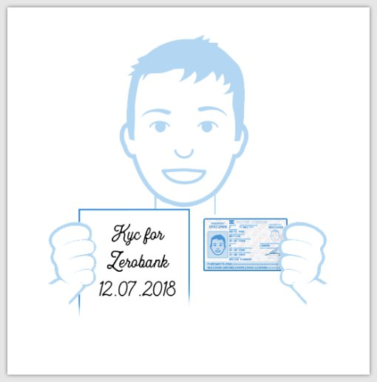  After that, the technical support department will be able to carry out technical work, after which you will be able to restore access to Google Authenticator.
You do not have access to the mail to which the account is registered | Write an email to support@skyway.capital. The email should include your full name in English and a selfie with your passport and a piece of paper with the current date on it.  Example of selfies:  After that, the technical support department will be able to carry out technical work and change the authorisation email on the website.  You will then receive all login instructions to your new registered email address.
You have access to email and Google Authenticator, but don't know your password | Use the password recovery function when logging in  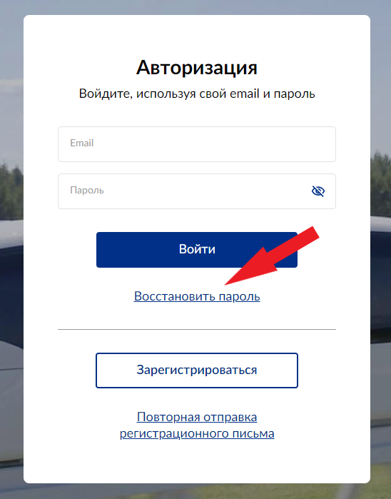

If you have further questions, contact technical support (support@skyway.capital).

Sincerely,
SWC Team.

